**TITLE OF PROJECT**

**Capstone Project Proposal**

**Submitted by:**

**101903543 Aditya Kumar**

**101903625 Rohan**

**101903514 Saarthak Bhatia**

**BE Third Year- COE**

**CPG No. 151**

Under the Mentorship of

Dr. Rajkumar Tekchandani

Name of Faculty Mentor

Designation



**Computer Science and Engineering Department**

**Thapar Institute of Engineering and Technology, Patiala**

**MONTH & YEAR**

**TABLE OF CONTENTS**

* Mentor Consent Form <3>
* Project Overview <4>
* Problem Statement …..
* Need Analysis (1 Page) …..
* Literature Survey (3 Pages) …..
* Objectives
* Methodology
* Project Outcomes & Individual Roles
* Work Plan
* Course Subjects
* References

**Mentor Consent Form**

I hereby agree to be the mentor of the following Capstone Project Team

| **Project Title:** | | |
| --- | --- | --- |
| **Roll No** | **Name** | **Signatures** |
| 101903543 | Aditya Kumar |  |
| 101903625 | Rohan |  |
| 101903514 | Saarthak Bhatia |  |
|  |  |  |

NAME of Mentor: Dr. Rajkumar Tekchandani

SIGNATURE of Mentor: . . . . . . . . . . . . . . . . . . . . . . . . . . . . . . . . . . . .

NAME of Co-Mentor(if any): ……… . . . . . . . . . . . . . . . . . . . . . . . . . .

SIGNATURE of Co-Mentor: . . . . . . . . . . . . . . . . . . . . . . . . . . . . . . . . . . . .

**Project Overview**

* Truly meaningful reform of India’s agricultural sector will require a comprehensive package of measures, to address not just how food is sold but also the entire supply chain, from production to processing to distribution. Solutions must balance multiple interests: food security for the nation, fair returns for producers, growth prospects for the private sector, and the creation of new employment opportunities in rural India.We are determined to create a system for counting the number of sacks entered into the warehouse and count them. We would be creating a working model to count the number of sacks which are stored in the warehouse and would be updating it to the database and these changes would be reflected in the application.
* Indian agriculture is not an exception for this, now India is facing two main problems concerning agriculture. India tried to be self-sufficient in agriculture through the five year plans. After independence by taking systematic efforts due to their unique importance, agriculture gets more and more attention in every five year plan and top priority is given for the development of agriculture in our Country.
* India is experiencing a high rate of economic growth in the last two decades but the growth has been coupled with high rate of food price inflation. The growth has been very uneven across sectors with agriculture remaining very sluggish. The increase in per capita income has significantly increased the demand for food but agricultural production has failed to keep pace with the growing demand. . There is no long run relationship between money supply and agricultural price. Increasing public expenditure and unfavorable foreign exchange rate have some effects on price although the results are not robust.
* Here we tried to make a project to help farmers as well as normal households here we are trying to create transparency between the government and farmers moreover normal households. This project will help the farmers to get the right price for the crops they have sown and reaped. For households this project will be telling the availability of the crops ,hence this will be creating transparency for the farmer ,government and households. We will be trying to make a warehouse in which we would be trying to calculate the weight using sensors so that we can sense the weight set for a sack. We store information for particular workers holding their weight and other details and therefore adding the weight of a sack to its weight would be counted as In this project we can prevent a rise in the price of grain or other edible items during times of inflation. This would be a great help for farmers and the public and we will connect this via app or website so that there is transparency and can later be shared with other peoples.
* India needs this type of technology because the consumption for the food is very high so high demands leads to high rates and thus the prices will be shooting and poor people won't be able to eat. The death rate because of food is increasing year by year and countries with most population suffers the most.

**Need Analysis**

* India largely depends on the agriculture sector. Besides, agriculture is not just a means of livelihood but a way of living life in India. Moreover, the government is continuously making efforts to develop this sector as the whole nation depends on it for food. But some of the brokers which are government appointed i.e., government market where farmers sell their crops at a certain MSP(minimum selling price).
* The payment of the crops is sanctioned after sometime between that time those officials try to keep some part of the crop in some other warehouse or reservoirs and when time of payment comes they keep telling innocent farmers that their crops have been destroyed by bad weather or some insects. So due to this they keep their reserves full. When the time of some mishappening comes i.e., better known as inflation comes they sell those crops or edible items at higher prices. Snatching the livelihood of hardworking and innocent farmers and earning profits from the normal households this condition is called inflation.
* Inflation is the decline in purchasing power of a given currency over time. A quantitative estimate of the rate at which the decline in purchasing power occurs can be reflected in the increase of an average price level of a basket of selected goods and services in an economy over some period of time. The rise in the general level of prices, often expressed as a percentage, means that a unit of currency effectively buys less than it did in prior periods.
* This project presents a proposed model for Smart Agriculture to develop a real time monitoring system for counting the number of sacks of crops stored in the warehouse. It will also be possible to control various operations of the field remotely from anywhere, anytime by mobile as well as web application. The IOT based agricultural monitoring system has been used to maximize the profit for farmers and the public,also creating transparency for removing inflation which creates problems. for all yield of crops by monitoring the count of sacks and thus providing the required information to farmers as well as to the whole nation remotely. This system can be implemented in any type of warehouse used for food storages. The use of IOT over the other technology one aides for deploying it in any type of environment for monitoring, making it flexible.
* This system will tell us about the number of sacks stored in the warehouse of the location and sharing of the data with all. For instance we will open this app and will get the data we desire to see, that is the number of sacks stored and when it was stored. So there would be no inflation situation and we are providing transparency. So this project will be helping in analyzing the total food available in country and adequate pricing for the food so that richer as well as poor people can afford as food is the basic need for the living and no one should be deprived of it.

**Literature Survey**

* You need to carry out a detailed survey in your respective field (3 pages).
* Present that literature survey of the systems/products/projects already existing in real world in this section.

**Objectives**

* At the end of the final evaluation of the capstone project, these objectives will be used to judge your project completion status.

**Methodology**

* You need to list the methodology of achieving the set objectives, in this section.

**Work Plan**

* You need to give a short work plan which you will set for achieving the set objectives, in this section.
* Sample:-

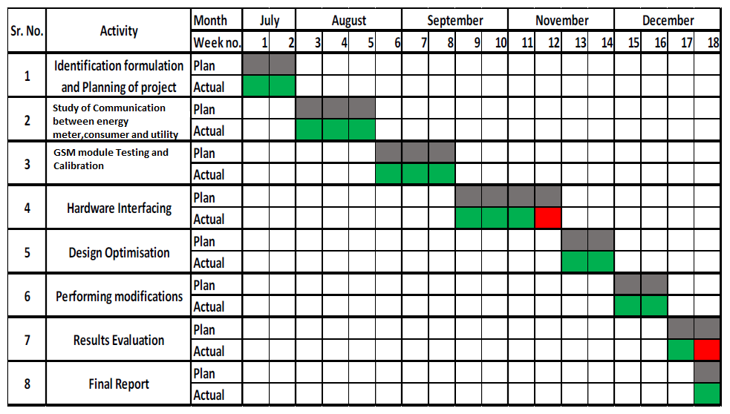

**=**

**Project Outcomes & Individual Roles**

* Here, you need to list the final outcomes/ products/ systems/ deliverables of your capstone project.
* The individual team member role must also be clearly specified in this section.

**Course Subjects**

* In this section, you need to list the course subjects that will be used (in the form of conceptual knowledge or practical skills sets) during the successful execution of your capstone project.

**References**

**Formatting Guidelines**

* Project Report Type:  Transparencies and tape bound
* Number of Copies: 1 per Project group (Max pages 15)
* Running text should be justified, figures and tables center aligned, no space before full stop etc.
* Use **passive voice** in text.
* Paper Size (orientation): A4 (portrait)
* Margins: 1” top / bottom / right and 1.5” left
* Font Type: Times New Roman
* Font Size: 16 bold for Section names, 14 bold for headings and 12 for normal text
* Line Spacing: 1.5 throughout
* Page Numbering:  Bottom center of page in the format – Page 1 of N
* All table and figure captions in size 10 sentence case, table captions on top and figure captions below the figure.
* All figures and tables quoted in the text with explanation.
* No figures and equations should be copied. Please use **smartdraw/ visio for figures and Mathtype** for equations.
* References (The listing of references should be typed 2 spaces below the heading “REFERENCES” in alphabetical order in single spacing left – justified.  It should be numbered consecutively (in square [ ] brackets, throughout the text and should be collected together in the reference list at the end of the report. The references should be numbered in the order they are used in the text. The name of the author/authors should be immediately followed by the year and other details). References should not be cited from Blogs, Twitter etc. but should refer to good Journal or Conference papers. Typical examples of the references are given below:

**REFERENCES**

[1] Ariponnammal, S. and Natarajan, S. (1994) ‘Transport Phonomena of SmSel – X Asx’, Pramana – Journal of Physics Vol.42, No.1, pp.421-425.

[2] Anderson T. , Peterson L., Shenker S., Turner J.(2005).Overcoming the Internet impasse through virtualization. IEEE Computer, 38(4):34-41.

[3] W. Zeng, H. Yu, C. Lin. (2013, Dec 19). Multimedia Security Technologies for Digital Rights Management [Online]. Available: http://goo.gl/xQ6doi